**LAB 1**

**Ashi Tyagi, NUID: 002706544**

**Part 1:**

**Part 2:**

To ensure data integrity & business rules certain conditions must be met:

1. First, we must make sure that the intended primary key attributes of the parent entity are necessarily present in the child entity. This entails that the inherited attributes of the parent entity to the child entity must be mandatorily present. In the above example the primary key attributes of PatientID and the TestID (foreign keys for Result entity) must be necessarily present in the Result entity attributes.
2. Secondly, we must ensure that referential integrity constraint is also met for the foreign key attributes present. This implies, for the above example, that we must ensure the values added to the Result entity are correct and matches the original values entered in the Patient and Test entity.
3. Lastly, we must ensure that the combination of the foreign key attributes present in child entity is original or unique. For example, the combination of foreign key attributes present in the Result entity, if made, must be unique. We can enforce this by creating a unique index of the combination of original key attributes.

**Part 3:**

JSON file:

Imported Data

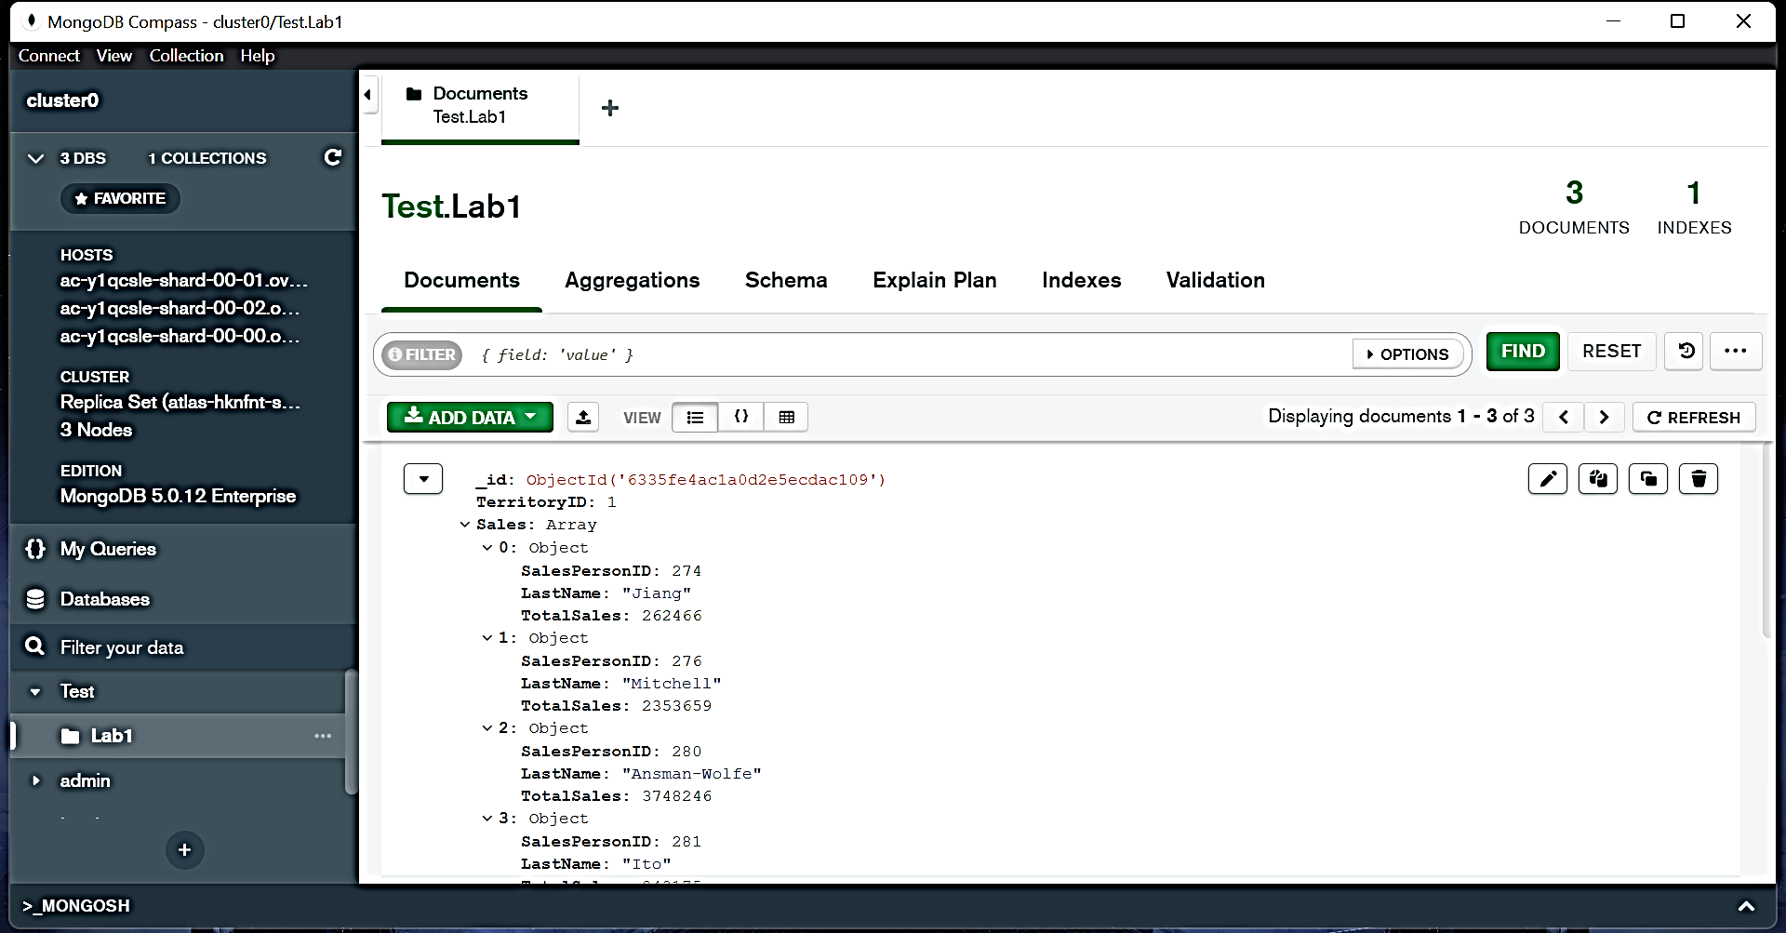

Aggregations

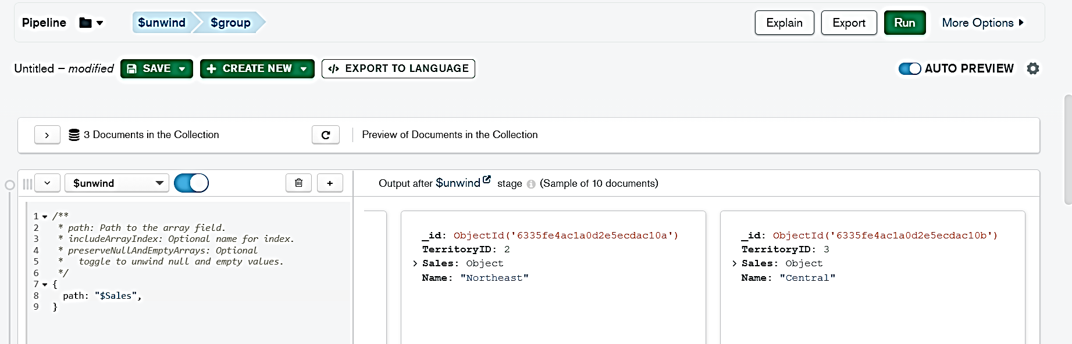

Total Territories

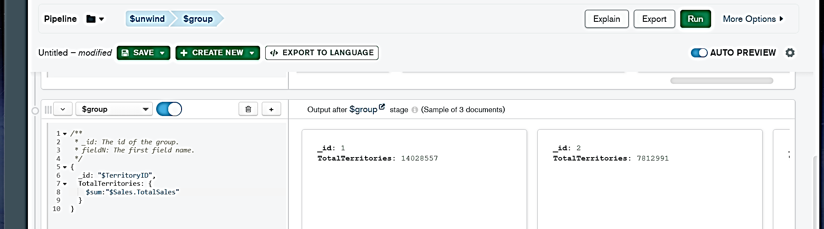

Result

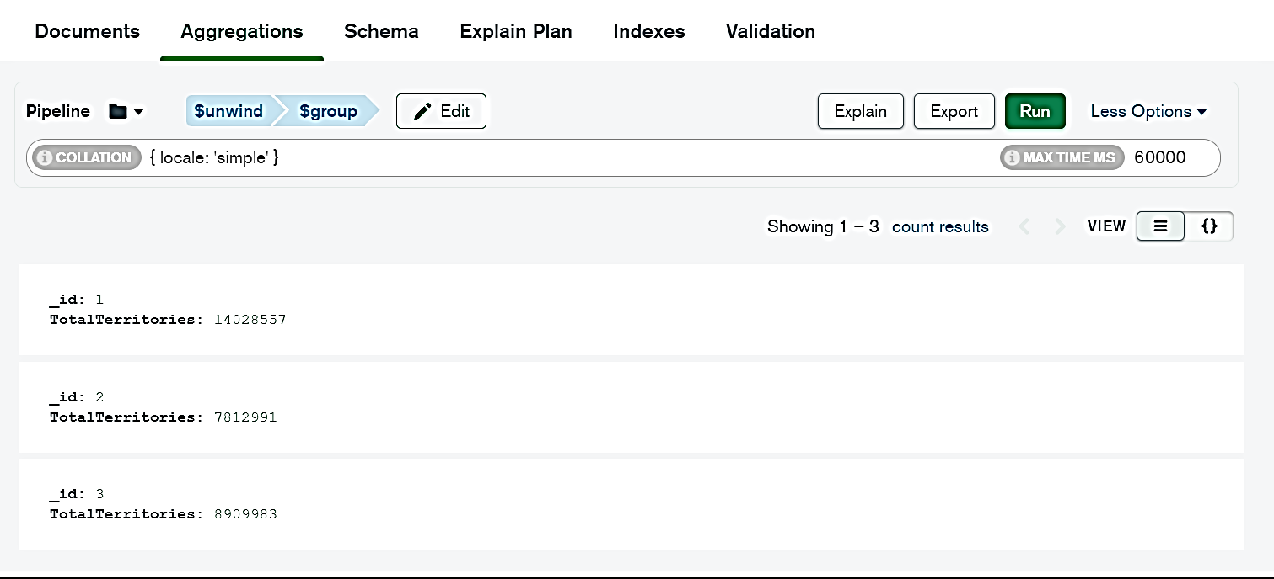

**Code:**

[{

$unwind: {

path: '$Sales'

}

}, {

$group: {

_id: '$TerritoryID',

TotalTerritories: {

$sum: '$Sales.TotalSales'

}

}

}]